**JavaScript Project**

**Team 1**

**Project 1 – New Navigation Design**

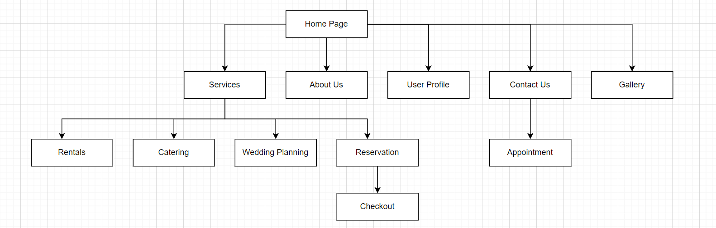

**Project 2**

Choose one of the web pages from your team website to enhance the user interface with at least two functions.

User_profile.html –> user_profile.js

All html pages -> permission.js

All html pages except user_profile page -> banner.js

Reservation.html -> reservation.js

Contact.html -> contact_us.js

Checkout.html -> checkout.js

**Project 3**

Choose one of the web pages from your team web site to enhance with code that uses an array and a loop.

Reservation.js used in reservation.html.

**Project 4**

Draw the DOM tree for an HTML document.

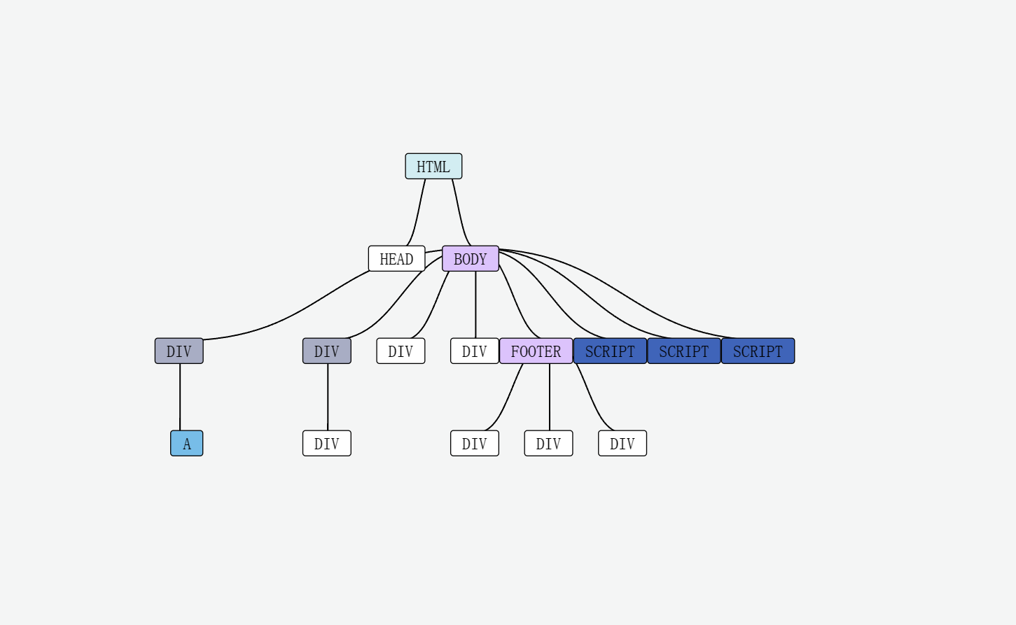

**Project 5**

Add validation code to all forms on your team website.

Validation in: Log in, user profile, registration, checkout, contact form.

**Project 6**

Add a page that enables users to add data to a table by entering data in a form for the contents of one row at a time.

Please see reservation.html (uses reservation.js)

**Project 7**

Enhance the feedback form in your project to enable users to choose one or more options from a list of at least five options. Include code that adds user selections to either an array or an object and ensures that if a user deselects one of the options, it is removed from the array or object. Add code to convert the array or object to a string.

Please see contact.html (uses contact_us.js)

**Project 8**

We have added new pattern validation to phone number input.

**Project 9**

Identify data provided by an Ajax service that you would like to include in your group website.

Advice API used in the home page. Random advice from api.adviceslip.com/advice.

**Project 10**

Examine the documentation of jQuery methods and properties at api.jquery.com. As a group, pick a jQuery method that would enhance the appearance or function of one or more pages of your group website.

We used the val() and text() jQuery functions in the user_profile.js, focus() in check_out.js, hide() and show() in reservation.js